# Week 2

## Week 2 Reading

**They Say/I Say: the moves that matter in academic writing**

* Basic moves are so common that they can be represented in “templates” to help you structure things
* State your own ideas as a response to others (summarize their work first)
* As opposed to what?
* King’s letter from Birmingham jail
* “they” must represent some wider group that readers might identify with
* Listen before you leap
* It is not plagiarism to recycle conventionally used formulas
* Disagree and explain why, agree but with a difference, agree and disagree simultaneously

**Fighting Poverty is the US and Europe**

* How much do different countries take from the rich to give to the poor?
* The poor benefit both from transfer programs and publicly provided goods
* Governments also distribute along non-income based lines
* Flows from rich to poor are much larger in Western Europe
* Magnitude and composition of government spending in Europe and the United States
* 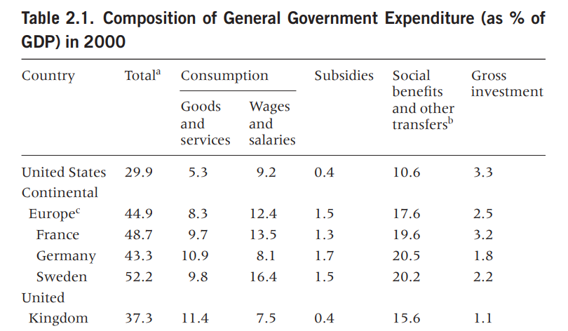
* Largest differences between the US and Europe are in transfers to households and subsidies
* Public investment is much higher in the US than in Europe
* Western Europe since WW2 has been a free rider on defense provided by the US
* U.S. system of transfers would have to be exceptionally well-targeted for the U.S. poor to receive more than the continental European poor, given the overall size difference
* 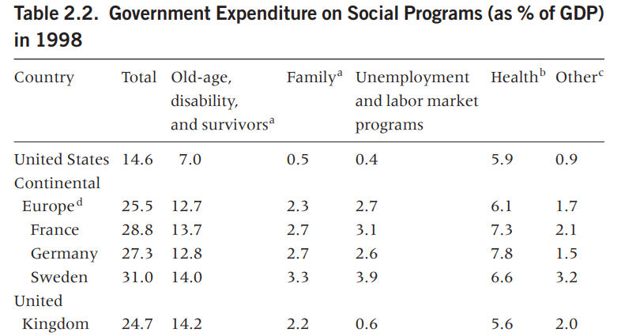
* In all categories except health, the US spends a smaller portion of GDP than the European average
* Social spending in the United States was less than 15 percent of GDP in 1998, whereas the European average was 25.5 percent
* From the very beginning of the expansion of the public sector in the late nineteenth century, the United States and Europe show very distinct patterns
* 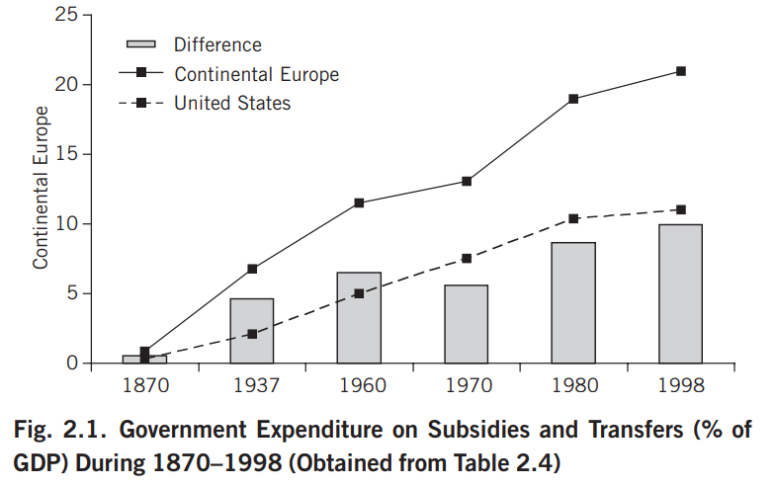
* The difference is long-standing, not the result of differences specific to a certain period or event
* Did not compare relative efficacy
* Income inequality both before and especially after taxes in worse in the US
* The greater inequality in the United States does not stem from the top decile being particularly wealthy relative to the median, so much as from the bottom decile being particularly poor (the American poor are really poor)
* Economic costs of the welfare state are extremely complex
* Certain aspects of redistributive policies, such as a good public education system, may foster human capital accumulation
* Distortions, mistargeting, and the growth of overprotected minorities (public employees, certain retirees, and union members) are common even in relatively well functioning welfare states

**A Cross-National Perspective on the American Welfare State**

* US protection against standard social risks is generally less comprehensive and less generous than other rich democracies but also relies most heavily on private markets
* Core social insurance policies at the federal level developed somewhat later than in Europe
* Our system generates worse outcomes in health, education, poverty, inequality, crime, homelessness, and the like
* US places overemphasis on the elderly
* Liberal welfare states rest on a political coalition that includes proponents of individualist and market-oriented philosophies
  + Pushes individuals to secure their own livelihoods
* Conservative corporatist aims to protect the standard of living achieved by workers and their families during their working lives
  + Occupational welfare state
* Social Democratic is a welfare state that emphasizes solidarity across classes and reduction of inequality
  + Generous citizen-based benefits
* US relies on the tax system as a welfare delivery device to a much greater extent than other rich countries
* US links earning-related old-age benefits to employment
* The United States spends more than twice as much on health care per capita, from public and private sources, as the average rich OECD country (mostly due to higher prices)
* A national system of unemployment insurance developed late in the United States (1935) compared to the United Kingdom (1911), France (1914), or Germany (1927). Each U.S. state operates distinct unemployment insurance schemes, but benefits are generally lower and of shorter duration in the United States than in most other developed OECD countries
* US has an unusually liberal labor market
* Temporary Assistance for Needy Families (TANF) program allows for considerable state-level discretion in benefits and eligibility
* The United States is also a major outlier in the area of policies for families and children: paid parental leave, child allowances, public financing, and provision of care for young children
* Government support of owner-occupied housing, if it comes at the expense of social (public) housing, is likely to limit income redistribution
* *Structural characteristics of the American welfare state:* 
  + Private provision
  + Decentralized discretion
  + Logic of deservingness
  + Elderly orientation

## 8/29 – How do policy regimes vary across the world? (1)

* All of your writing must be valuable (change how your reader thinks about the world)
* For which audience? For what purpose?
* Response paper audience is peers, goal is to change how they think about the world

*American Exceptionalism:* America is great so we don’t need to learn from other countries OR America is so unique we can’t learn from elsewhere

Is the US really exceptional? How can we compare ourselves to different countries?

Questions of measurement and classification

2 divergent approaches:

* **Lump:** put countries into small number of groups based on broad similarities
  + Devil is in the details
* **Split:** put countries into a larger number of categories based on small differences
  + You can miss the forest for the trees

## 8/31 – How do policy regimes vary across the world? (2)

Alesina & Glaeser

* Europe spends more on redistributive policies than the US
* It’s better to be poor in Europe than in the US
* This isn’t a new phenomenon (been the case since late 1800s)
* Not a normative analysis

Other attempts as classification are more complicated

Why do countries have welfare states? What do you think countries should use their welfare states for?

2 forms of redistribution:

* *Vertical redistribution:* welfare states as Robin Hood, transfers from rich to poor, redistribution across groups in society
* *Horizontal redistribution:* welfare states as piggy banks, hedge against risks (disability, old-age, unemployment, children), redistribution across life stages

Each country dedicates different amounts of attention to vertical or horizontal redistribution. These choices reflect different beliefs about what governments should do and for whom.

Egalitarian = commitment to equality

Conservative = not interested in changing the status quo

Solidaristic = we’re all in this together and have a responsibility to take care of each other

Individualistic = we’re in things alone, we don’t have an obligation to help different people

The Three Worlds of Welfare Capitalism

* *Liberal:* egalitarian and individualistic
  + You are responsible only for yourself (you buy insurance to hedge against risks)
  + Dependence on other people is bad, but capitalism can lead to unacceptable inequalities between individuals
  + Goal is a minimum standard of well-being – not equality
  + Influential in shaping WWII welfare states, sometimes called the Beveridge model
  + Limited horizontal, but some vertical redistribution (poor receive min income and relief, but most social insurance comes from the market)
  + Qualification process is means-tested, stigmatized, and less desirable than work
  + Reduced inequality in a limited capacity
* *Social Democratic:* egalitarian and solidaristic
  + Enthusiastically solidaristic, but they are moderate in their means
  + Goal is a more human and equal form of capitalism, if markets are failing you the
  + Lots of horizontal and vertical redistribution, a ton of taxes
  + Citizenship-based rights to an extended array of social benefits
  + No strict qualifying conditions
  + Relatively low levels of inequality but at a cost to growth
* *Conservative Corporatist:* conservative and solidaristic
  + People will be protected against risks, but there’s no effort to reduce inequalities
  + Compassion for the disadvantaged within the bounds of a hierarchical, family-based social order
  + Social policies ensure stability and protect workers without changing society
  + Developed by Otto von Bismarck to weaken trade unions (Bismarckian Model)
  + Focus on horizontal, not vertical redistribution
  + Insurance for workers’ risks
  + Coordination between business, workers, and government interests
  + Employed are well-protected insiders, others are outsiders whose social protection often dependent on their family (heavily gendered)
  + Inequality is largely preserved

# Week 3

## Week 3 Reading

**Which Country Has the World’s Best Health Care? (Introduction)**

Health care is path dependent

Rankings are not consistent but agree that the US’s system is not great

So much of health care is value driven

7 major challenges common to every system:

1. Health care cost pressures
2. High and rising cost of drugs
3. Reducing inefficiency in the provision of care, as well as curbing unnecessary care in the system
4. Coordination of care for patients with chronic illnesses
5. Mismatch between health care delivery institutions and the population’s chronic health care needs
6. Provision of mental health care
7. How to provide long-term care and how to pay for it

**Eightfold path summary**

1. Define the problem
2. Assemble some evidence
3. Construct the alternatives
4. Select the criteria
5. Project the outcomes
6. Confront the trade-offs
7. Decide
8. Tell your story

Policy analysis is done in a wider context of psychology and complexity, including:

1. Policymaker psychology
2. Policymaking complexity

**Hacker: The Historical Logic of National Health Insurance: Structure and Sequence in the Development of British, Canadian, and US Medical Policy**

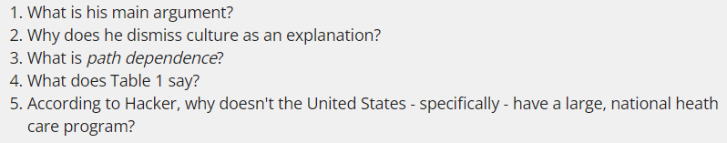

* Government-sponsored healthcare is both a staple and highly controversial
* National culture doesn’t convincingly explain the divergent health policies enacted by industrialized democracies in the 20th century
* Emphasize political institutions in which decisions are made
* The prospects for policy change depend critically on the opportunities and constraints created by government institutions
* 3 most common explanations for difference: economics, culture, and interest groups
* Circular logic: the proof that Americans did not want national health insurance is that they did not get it (we don’t have the data to actually assess opinions over time)
  + Britain gave birth to antistatist liberalism
* Founders created a constitutional structure that limited and channeled popular demands and hindered rapid policy change
* unification of powers in parliamentary systems facilitates swift legislative action and offers a more centralized form of accountability at the ballot box
* culturalists tend to overlook or at least downplay the historical interaction between political culture and policy change
* path dependence is meant to suggest the importance of “temporally remote events, including happenings dominated by chance elements rather than systematic forces”
  + like black swan events (but could be small and unnoticeable things)
* Policies may alter administrative capacities, create incentives for group formation, teach specific lessons to policy makers, or give rise to widespread public expectations or vast networks of vested interests
* Important policy choices: degree to which private health insurance was allowed to develop and the form that private plans took, the initial target of government insurance programs, and the relative timing of public efforts to bolster the technological sophistication of medicine vs, to increase the access of citizens to healthcare
* US started with the most costly and difficult groups to insure (Britain started with wage earners)
* The very different political forces that led to the establishment of the NHS, the creation of Canadian Medicare, and the failure of national health insurance in the United States can all be understood through a common theoretical lens. This lens requires that we look at the development of health policy not as a series of discrete political struggles, but as an ongoing historical process in which past public policies and political battles shape what is possible in the future.

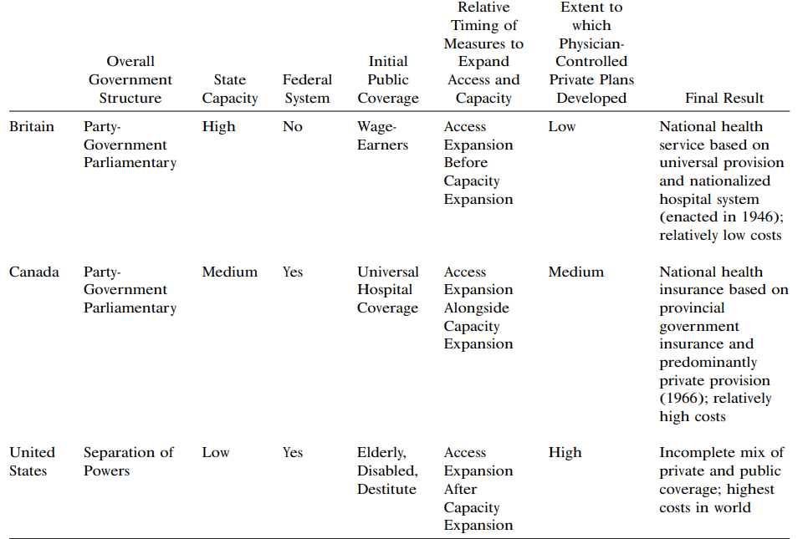

## 9/5 Lecture – Why is policy change slow?

* Welfare states benefit women to different degrees
  + Can women enter the labor market?
  + Do women have freedom from patriarchal control?
  + Do women have equality in the labor market?
* The Three Worlds model only identifies some aspects of reality
* If countries rarely fit neatly into these boxes, why use these classifications at all?
  + Crude distinctions can help us understand big trends in income inequality
* Good classifications help us understand the world and navigate within it
  + But they always simplify reality

## 9/7 Lecture – How do past policies constrain future policies?

How is the US an outlier?

* Private provision
  + US welfare relies on the market to supply social welfare benefits (healthcare, childcare, occupational pensions, housing, higher education)
  + Leads to a submerged state
* Decentralized discretion
  + Wide variety of responsibilities and powers delegated to subnational units across the world
  + Standards are national for most countries
  + One acute example of this is unemployment benefits
* There are structural differences but there are also a lot of sectoral differences
  + Old-age and survivor pensions
  + Health care
  + Labor market
  + Housing
* Case of the US shows how lumping can miss important differences
* Lumping vs. splitting have both strengths and weaknesses that highlight different things

Make healthcare more manageable by splitting the field into 7 key challenges

Give strong problem statements linked to each challenge

Good prob statements: evaluative/normative, common language, quantify, diagnose problems, avoid cause and effect claims without analysis, avoid inserting solutions

# Week 4

## Week 4 Reading

**Punctuated Equilibrium Theory: Explaining Stability and Change in Public Policymaking**

* Punctuated Equilibrium Theory (PET): although generally marked by stability and incrementalism, political processes occasionally produce large-scale departures from the past
  + Embedded is an implicit theory of individual and collective decision-making
* Statis, rather than crisis, typically characterized most policy areas
* American political institutions were conservatively designed to resist many efforts at change and thus to make mobilizations necessary to overcoming established efforts
* Agenda access does not guarantee major change, because reform is often blunted in the decision-making stage

**Policy Paradigms, Social Learning, and the State: The Case of Economic Policymaking in Britain**

* The most important influence in learning is the previous policy itself
* Key agents pushing forward to learning process are the experts in a given field of policy
* Emphasizes the capacity of states to act autonomously from societal pressure
* What is the actual role that ideas play?

*What are the 3 elements of policymaking?*

* Process whereby one policy paradigm replaces another is more sociological than scientific
* Issues of authority are likely to be central to the process of paradigm change
* Instances of policy experimentation and policy failure are likely to play a key role in the movement from one paradigm to another

1. Overarching goals
2. Techniques or instruments
3. Precise setting of these instruments

*What are the 3 types of policy change? For each type what is the impetus and which actors are responsible for making policy?*

1st order

* Features of incrementalism, satisfying, and routinized decision making we normally associate with the policymaking process
* Process in analytical
* Example is budget making
* Flow often comes from institutional and political norms

2nd order

* Development of new policy instruments
* Less frequent junctures
* Example: altering the instruments of macroeconomic policy without radically altering the hierarchy of goals behind policy
* Fit with image of learning put forth by state-centric theorists
* State acts rather autonomously

3rd order

* Movement from one paradigm to another
* Involves the accumulation of anomalies, experimentation with new forms of policy, and policy failures that precipitate a shift in the locus of authority over policy and initiate a wider contest between competing paradigms
* Much more dramatic changes
* Example: monetarism vs. Keynesianism
* Radical shift in the hierarchy of goals guiding policy, instruments relied on to effect policy, and settings of those instruments
* Policy paradigms are often selected because of their political appeal
* Politicians and the media play the greatest role in this process of policy change (not civil servants or policy experts)

*What is a policy paradigm?*

* Framework of ideas and standards that specifies not only the goals of policy and the kind of instruments that can be used to attain them but also the nature of problems they are meant to be addressing
* Concept of policy paradigms can help u understand variations in the autonomy of the state
  + Why is the same state sometimes more or less autonomous from social change?
* Policy paradigms have the greatest impact in institutional settings where policy is superintended by experts or administrators with long tenures, because it gets built into operating procedures and departmental routines

*What is required for a third-order policy change?*

* Shift in policy paradigm
* Stark dichotomy between state and society is dissolved

*How does this argument relate to other theories we’ve covered?*

* 3rd order change seems like the only way to escape path dependence
* Shows that governments face both electoral and government constraints

## 9/12 Lecture – Why is policy change typically slow?

* What – if anything – should governments do about inequality?
* How should governments protect citizens from risks across the lifespan?
* To help us make sense of how different countries answer these questions differently, we need to understand the mechanisms of policymaking processes

1. Muddling through (incrementalism)
2. Path dependence
3. Hacker’s 4 models of policy change
4. Hall’s 3 types of policy change
5. Punctuated equilibrium

* Public policy programs started in the 60s
  + Helped introduce a “scientific” approach to creating policy
  + Rationalism has its critics

Muddling through

* Charles Lindblom
* “The Science of ‘Muddling Through’” published in 1959
* Lays out the Root and Branch methods of policymaking
* Rational-Comprehensive (Root)
  + Clarification of values/objectives distinct from analysis of alternative policies
  + Policy formulation approached through a means-end analysis
  + Identify ends first
  + “good” policy is the most appropriate means to desired ends
  + Every relevant factor needs to be taken into account 🡪 every relevant factor needs to be taken into account
  + Theory is heavily used
* Successive Limited Comparisons (Branch)
  + Selection of goals and analysis of alternatives are closely intertwined
  + Means and ends are not distinct
  + “good” policy is one that various analysts find themselves directly agreeing on 🡪 a “good” policy is one that gets passed
  + Analysis is drastically limited
  + Constant tweaking reduces reliance on theory
* Lindblom critiques of Root Model
  + Lindblom thought the root model was unrealistic
  + Policymakers rarely identify clear objectives
  + Only a limited set of alternatives are considered
  + We can never predict the consequences of policies
  + We can such big mistakes, so he thought it was bad
  + Limited learning, can’t isolate effects of an overhauling policy
  + Ignores stakeholders
* Muddling through is essentially the Branch method (or incrementalism)
* There are many arguments against incrementalism
* Basics of Path Dependence
  + When first addressing a problem, there are a lot of options
  + Each subsequent decision creates a path from which it is hard to deviate even if there are better options in other paths
  + Eventually you may get to a point of lock-in
  + The status quo matters for policy making and what you can do in the future
  + “once a country or region has started down a track, the costs of reversal are very high”
  + “the entrenchments of certain institutional arrangements obstruct an easy reversal of policies”
* Mechanisms of path dependence
  + Sunk costs: money is already invested in a tech/policy that can’t be recovered
  + Vested interests: powerful actors have a stake in the status quo
  + Learning/adaptation: societal actors get used to existing policy
* Politics of path dependence
  + Elected politicians prioritize short-term consequences
  + Shorter terms? Shorter time horizons
  + Long-term costs and benefits typically have a limited effect on choices
  + Political actors have powerful interests in staying on the path:
    - Switching costs are borne in the short-run
    - Benefits from switching will generally only accrue in the long-run

## 9/14 Lecture – When is policy change quick?

**Path Dependence** – what does it look like?

* Multiple equilibria - the same initial conditions can produce a wide range of outcomes
* Contingency - it becomes harder to shift paths later in the process
* Timing and sequencing matters – it matters when events take place, early choices are more consequential
* Inertia – once reached, equilibria can be very resistant to change

Path dependence helps explain why we rarely see big policy change in established areas… even when current policies are bad

Structures and conjunctures as influences on policymaking

**Structures** – slow-moving constraints on policymaking

* Interests
* Ideas
* Identities
* Institutions
* Shape the likelihood and form of policy change
* These look different across countries

**Conjunctures** – short-term opportunities for change

* Impetus for change

Hacker: why does health insurance look so different between Canada, UK, and US

* They say: cultural values, economic explanations, interest group explanations
* Hacker says: historical path dependence perspective, cultural values aren’t that different
* Opportunities are rare, but policy windows (conjunctures) have opened in all 3 countries
* In the early years, all 3 countries had similar dilemmas
* 3 early choice had long legacies:
  + Emergence of private insurance created vested interests; physicians opposed government intervention
    - Physicians ended up with an intrinsic interest in maintaining the status quo
  + Treatments of initial expansion determined ease of further expansion due to cost
    - US insured the most vulnerable, which was really expensive, and these were designed to not expand to other groups
  + Technological sophistication strengthened some interests, while making tradeoffs difficult
* Cost vs. access tradeoff
* Late and limited reforms made it difficult to expand access in the US
* Before WW2, world of social insurance, horizontal welfare was the norm (UK system formed)
* After WW2, we were in an era of universality (Canada system formed)
* Oil shocks/stagflation, pressure for cutbacks (US healthcare reform fails)
* When are opportunities for fundamental policy change arise, the form that national health policies take depends on market structures, policy ideas, interest group, strategies, and public views as well as on the prevailing ideological and economic climate
* Prospects for policy change depend critically on the opportunities and constraints created by the government institutions

Hacker’s take

* In any given conjuncture, Hacker’s argument allows for the interplay between different structures
* Likelihood of change is shaped by institutions
* Form that change takes depend on ideas, interests, and identities
* Political decisions make or not made in turn feed back into future political struggles, progressively limiting the range of possible outcomes
* Original ideas:
  + Doctors are a malign force in his story (they push back most on insurance reforms)
  + Attitudes towards healthcare are as much a consequence as a cause of policy choices
  + US’s quality of care has helped undermine access to care (it’s more expensive to insure people)

Path dependence applications:

* Is the current policy the result of a long, path dependent process?
  + Health care is very path dependent
  + Emerging areas are less path dependent
* What are the structures constraining change?
* What are the conjunctures that might make change possible?
* How might you change structures and create (or take advantage of) conjunctures?

# Week 5

## Week 5 Reading

**Bounded Rationality and Policy Diffusion: Social Sector Reform in Latin America**

* Poor countries like Bolivia and El Salvador have privatized their social security systems even though they lack important preconditions for making private pension funds operate successfully
* Why do countries eagerly emulate foreign models that do not seem to fit their own domestic characteristics? Why do they adopt innovations despite lacking crucial prerequisites for making the new policy scheme work?
* Diffusion plays out differently in an area like social security in which a singular model exists vs. a highly complex field
* Many decision-makers participate in transnational networks that strongly influence choices at the national level and they engage in even denser cooperation and rule making at the international level
* International diffusion of democracy and markets has forged increasing homogeneity as alternative systems such as communism have collapsed and lost adherents
* In the social sphere, opposition to neoliberalism is particularly strong
* What are the motives of “Third World” government policymakers?
  + Rational choice/self-interest
  + Normative appeal and quest for international legitimacy
  + Appropriateness and legitimacy are pushed into the background
* External imposition vs. latitude for choice, legitimacy vs. self-interest, comprehensive cost/benefit calculation vs. reliance on cognitive shortcuts
* A distinctly bounded form of rationality prevails in the cross-national diffusion of policy innovations
* Latin American policymakers attracted to foreign experiences in more “accidental” logically arbitrary ways
* Policymakers rely on the heuristics of availability, representativeness, and anchoring
  + Enable people to cope with a flood of information
* Early success often gives rise to impressions of high promise
* How these biases affect policy choices
  + Availability heuristic makes us pay disproportionate attention to recent changes
  + Representativeness shapes how existing policies are evaluated in terms of quality and promise
  + Anchoring limits the adjustment that policymakers introduce to adapt a foreign import to the specific characteristics of their own country
* These account for the geographical clustering, wavelike progression, and basic nature of diffusion
* Utilitarian goals have been significantly more important than symbolic and normative considerations, especially in the area of social security reform
* Political actors seem to have a significant margin of choice and are not hugely influenced by external imposition
  + External conditions were often requested by domestic experts
* **Model diffusion:** spread of compact policy model
* **Principle diffusion:** decision-making units enact a principle adopted by a frontrunner be implement it slightly differently
  + Principles is a general guideline for designing programs or institutions
* *Characteristics of diffusion:* wavelike, strong geographical clustering, produces spread of similarity amid diversity
* Pension reform in Latin America has focused on enhancing efficiency through competition or privatization
  + Chile’s radical privatization in 1981
* Maxims in healthcare: guarantee universal health coverage by extending effective medical attention to the urban and rural poor, seeking to contain the constant increase in medical spending and to produce more and better services with the available resources
* External pressures are more effective in promoting general guidelines than complete models

**Learning from Comparative Public Policy: A Practical Guide, Step 3: Where to Look for Lessons?**

* A knowledge of history can help policymakers understand the programs they currently administer, but historical analogies are just quasi-lessons
* Process of drawing an analogy starts with the identification of a past situation that has one or more similarities with the present
  + Then used to preview how the current problem is likely to develop
* Conclusions that were valid in the past may not be valid today
* We typically look to **neighbors** and **distant friends** as case studies
* Contacts among English-speaking countries
* **Useful strangers** can offer fresh insights into the problem, especially when a similarity in conditions is combined with striking differences in outcome
* Don’t forget about cases that are too big or too good to ignore
* Lesson-drawing is about programs rather than programs rather than national power
* Use the logic of benchmarking and peer group review
* Where you look depends on where you are coming from and where you want to be in the future

## 9/19 Lecture – Case Selection Workshop

* Explaining the content of change: diffusion and bounded rationality
* *Weyland* identifies 2 types of ideas that spread across borders
* **Principles** – a guide/orientation for policymakers that can be fulfilled with several different policies
  + General and vague
  + Can take many different specific forms
* **Models** – a coherent blueprint that provides an integrated blueprint for implementing a given principle
  + Specific and concrete
* We use heuristics while we are learning and this can cause us to overlook things
  + **Availability:** people put more weight on vivid, memorable examples
  + **Representativeness:** people overestimate the extent to which a limited number of observations provide an accurate picture of reality
  + **Anchoring:** people are hesitant to move away from an initial example, no matter how arbitrary
* Cognitive heuristics and are worse for model learning

**Pension reform in Latin America**

* Latin America faced budget crises in the 1980s and 1990s – pensions played a part
* Chile undertook a radical privatization reform in 1981, guided by American-trained economists
  + Adjusts so a country doesn’t have to pay as much if the economy is going badly
* Chile became the benchmark country in Latin America, so other countries started copying it

*Neighbors*

* Countries that look as similar as possible
* Context and problem should be similar
* Similar countries may already have similar policies, leaving you little to learn

*Strangers*

* As different as possible
* Radically different insights can provide a fresh perspective
* Differences in cultural and political differences can hinder policy model transfer, particularly without adaptations

*Best practices*

* Look at countries that are highly successful or serve as notable examples of a given approach
* Provides a clear example of a different strategy – often successful
* Similar to strangers, context might influence policy success

## 9/21 Lecture – Wrapping Up Theories of the Policy Process

Hacker’s Four Modes of Policy Change

1. Drift
   1. Transformation of stable policy due to changing circumstances
   2. Many veto players
   3. Gridlock can produce major changes in outcomes when context changes
2. Conversion
   1. Internal administrative adaption of existing policy
   2. Many veto players
   3. Political actors are able to redirect existing policies
   4. Feeds off of rule ambiguity, multiplicity of political arenas
3. Layering
   1. Implement new policies without taking out old policies
   2. Few veto players
4. Revision
   1. Replacing what previously existed
   2. Few veto players

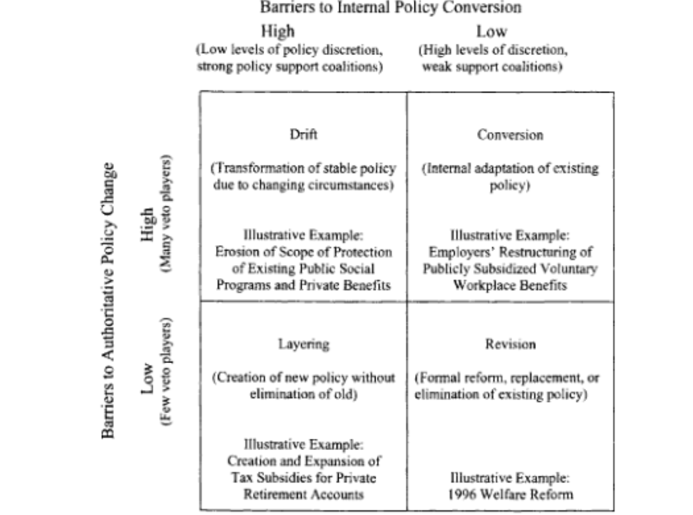

All types of policy change can be shaped by path dependent processes, but structures that reinforce path dependence make drift and conversion more common

Drift and conversion suggest that change – albeit gradual change – can happen in path dependent systems because they occur outside of legislative politics

* The processes are difficult to anticipate, monitor, and influence
* They turn normal patterns on their head

When you think about political feasibility, keep your eyes open for opportunities for drift and conversion

Hall’s Three Types of Policy Change

How can we make sense of drastic shifts in both policies and policy goals?

* Three central variables:
  + Overarching goals that guide policy in a particular field
  + Techniques or policy instruments used to attain those goals
  + Settings of these instruments
* **1st order:** routine adjustments to known policy instruments
  + Beliefs that current policy is generally good but could be tweaked to work better
  + Change originates with bureaucrats and experts and can often be done bureaucratically
* **2nd order:** changing policy instruments used to achieve shared policy goals
  + Beliefs that the current instrument isn’t working well, but the goals are sound
  + Change originates with bureaucrats and experts, but can require politicians’ actions
* **3rd order:** shifting the goals and instruments
  + Beliefs that the current goals are incorrect, often in response to crisis or accumulated failures
  + Requires political change and renovation of relevant experts
  + Policy paradigm shift
* Thomas Kuhn’s book on scientific revolutions
  + Scientific advances are not incremental
  + Existing communities are overtaken and replaced by other communities
  + The cause is a crisis prompted by new information and the inability of incumbent scientists to explain the world
* A crisis prompted by policy failure that can’t be explained by the existing paradigm
  + Result 🡪 search for new ideas
  + Only ends when supporters of a new paradigm secure authority
  + This requires political contestation
* Not all crises lead to policy paradigm shifts – there need to be a coherent alternative with empowered backers
* Not all policy areas are equally dominated by policy paradigms
  + Most likely in technical areas where decisions are made by experts with long tenures, the number of these areas grows as modern states take on more responsibilities

Punctuated Equilibrium Theory

* Explains different theories together to explain stability and change
* Why is policymaking typically stable and incremental, but can have big shifts?
* Extends hall by drawing attention to the role of power in paradigm shifts
* Actors who benefit from the status quo intentionally try to restrict policy making 1st and 2nd order changes, which they control 🡪 this causes stability over time
* Policymakers in macro politics (national legislative change) are constrained by bounded rationality
  + Serial processing: only one thing can be dealt with one at a time

# Week 6

## Week 6 Reading

**CRAAP Test**

* Currency
* Relevance
* Authority
* Accuracy
* Purpose

**Check Yourself with Lateral Reading**

* You need to understand where your information is coming from
* All information is created by someone for a purpose
* Many websites look legitimate when reading vertically because you’re only seeing what creators want you to
* Move from tab to tab, look at a lot of sources
* The more corroboration you have, the better
* You should use Wikipedia
* Information is made by people, but not all information is equally unreliable

**What’s the Matter with Scarsdale**

* People who would pay higher taxes often vote democratic
* Pocketbook issues aren’t the only ones that decide a person’s vote
  + People vote more on cultural attitudes
* the contemporary Democrat who fared best with the white working class was Obama
* rightward drift of workers has become an international phenomenon
* Some political scientists believe that Democrats talk too much about policy and not enough about values

**Fighting Poverty in the US and Europe – a world of difference - the ideology of distribution**

* today the poorest Americans appear to be more likely to stay poor than the poorest Europeans despite the fact that they often work longer hours
* Europeans are much more likely to believe that the poor are trapped in poverty and that their poverty is the result of forces beyond their control
* Americans believe that effort, not luck determines income (we think we live in a land of opportunity)
* Beliefs may be first causes
* ideology is more of an effect of the political success of the right than a cause of that success, and that the root causes of right-wing political success are institutions and heterogeneity
* ideology is created by political actors who use it to support their agendas
* Differences in popular beliefs about income mobility are shaped by politics and indoctrination, not by reality
* The opinion surveys confirm that Americans believe that (1) they live in a land of abundant opportunity, (2) there are no social classes and as a result, (3) anyone who remains poor, pretty much deserves to be poor
* The overall story of the American belief in mobility suggests that the belief in economic mobility has been a prop of the right, and that right-wing politicians have assiduously furthered that belief
* In Europe socialists actually got elected
* Because of racial fractionalization and American institutions, there was never a socialist government in the United States

**Democrats’ conundrum: Voters often don’t trust government to fix inequality**

* More Americans are believing that the income gap is a serious problem
* direct evidence of the causal effects of trust in government on redistributive policy preferences

## 9/26 Lecture

## 9/28 Lecture

# Week 7

## Week 7 Reading

**Martin J. Williams: External Validity and Policy Adaptation**

* External validity can be understood by the interaction between a policy’s theory of change and a dimension of the context in which it's being implemented
* **Mechanism mapping:** maps of policies theory of change against salient contextual assumptions to identify external validity problems and suggest adaptations
* There has been a recent global boom in impact evaluations
* A policy’s **theory of change** is a set of logical steps spanning inputs to activity outputs, intermediate outcomes, and final outcomes
* Context can include a wide range of factors
* External validity includes the **generalizability** of evidence and the **applicability** of evidence
* Evaluation evidence on a policy’s effectiveness in other contexts is likely to be more rigorous than available local information, but relying on this evidence from elsewhere requires strict fidelity to the original policy design.
* Mechanism mapping relies on the judgments of policymakers
* **external validity** refers to the extrapolation of its findings beyond the study sample to another population
* 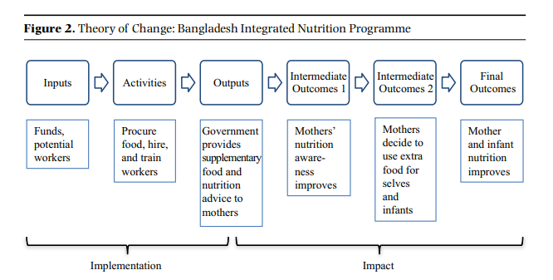
* mechanism mapping can be adapted to policies that are intended to lead to multiple "nal outcomes (e.g,. a cash transfer that is intended to increase consumption and improve child school attendance); to examine the likelihood of negative outcomes or side effects of the policy
* 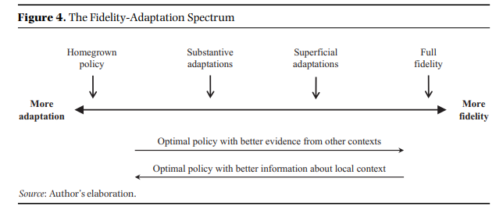

## 10/5 Class

**Punctuated Equilibrium Theory**

* Actors who benefit from the status quo intentionally try to restrict policy making to 1st and 2nd order changes, which they try to control
* Policymakers in macro policy are constrained by bounded rationality
* Most policymaking is dominated by **policy monopolies**: policy subsystems controlled by actors with shared interests
* **Policy image:** how policy members in policy monopolies agree that the public should understand an issue
* **Framing:** actively promoting to policymakers and broader public
* Policy monopolies work to maintain their position
* Most policymaking involves serial processing, not parallel processing
* Stability is actively created by actors in a policy monopoly
* Dramatic change happens when challengers disrupt the policy image created by policy monopolies
* Conflict expansion, venue shopping (push for change outside of policy monopoly venues)

# Week 8

## Week 8 Readings

**Racial Categories in Three Nations: Australia, South Africa, and the United States**

* race is a social construction
* racial formation argues that race is a process of racial formation
* racial categories in all three nations have been strongly influenced by colonization and the ideology of white supremacy
* Racial terminology reflects its basis in appearance
* Race is a constructed process, but racial legacies of the past continue to shape the present

United States

* 5 main categories: white, black/African American, Native American/Pacific Islander, Hispanic/Latino, and Asian
* Key historical events: colonization, slavery, the US Civil War, Jim Crow laws, and the US Civil Rights Movement
* Settlers were white and native Americans were “Indian,” all slaves were considered black (one drop rule)
* Policies aimed at racial equality maintained the importance of racial classification because to measure progress, race needed to be tracked
* The nation's answer to that question 'who is black?' has long been that a black is any person with any known African black ancestry

South Africa

* Key historical events: Anglo-Boer War, apartheid, and the anti-apartheid movement
* Whites are a minority in South Africa
* Mixed people were called colored

Australia

* Key historical events: the White Australia Policy, postwar European migration, and multiculturalism policies since the 1970s
* Racial superiority (and white supremacy) above aboriginal peoples
  + Reasons underlying dispossession began as economic
* For many years Australia has had a biracial outlook (black or white)
* There is now an Asian category and arguably a separate Indian category
* Australia does not collect population data by race except for those who are Aboriginal or Torres Strait Islander. It does collect information on ethnicity, highlighting the relative importance of ethnicity in that context.

**Race Policy in France**

* 5% of the French population is non-European and non-white
* Maintains a “color-blind” model of policy
* uses geographic or class criteria to address issues of social inequalities
* has developed more anti-racist policies, including to address hate speech
* France became a multi-ethnic society after World War Two, when millions of immigrants arrived
* In France even dealing with race brings connotations of Nazi Germany or Vichy France
* 1978 law specifically banned the collection and computerized storage of race-based data without the express consent of the interviewees or a waiver by a state committee
* Four principal elements of antiracist policies:
  + Bans hate speech, makes it punishable by law
  + Outlaws discrimination in employment and in provision of goods and services by public or private actors
  + Establishes provisions that allow the state to ban groups that seek to promote racism
  + Institutionalized the legal role of nongovernmental anti-racist associations as partners in fighting racism, permitting them to instigate and to take part in court cases of racism as “civil parties”—an official status that confers rights on associations-even when they have not been directly harmed
* Also banned Holocaust denial, judges can impose additional penalty on parties convicted of racist crimes, mandated annual report on racism

**Why Race in Brazil is Confusing**

* Definitions of race (particularly black and white) are mixed
* They can be interpreted as literal color or technical genetics
* Some people feel that race is relevant and others do not

**What Black America Means to Europe**

* An idea doesn’t exist if you don’t do something about it
* Internationalism and anti-racism of the European Left
* Political identification with moral struggle of Black Americans could shroud relative military and economic weakness
* Transnational protests have become more frequent because of social media
* The closer you are to the center, the less you need to know about the periphery
* Europe also has a history of exporting racism all around the world
* A significant proportion of Europeans believe that their country’s former empire is something to be proud of
* There is still prevalence of racism in Europe
  + Racism is less lethal though
* With what authority do Europeans get the challenge America over racism?
* drawing connections, continuities, and contrasts between the racisms on either side of the Atlantic invites something between rebuke and confusion from many white European liberal

**What We Can Learn From the Rise and Fall of Political Blackness in Britain**

* “political Blackness” 🡪 umbrella term that encompassed minorities with family origins in Asia and the Middle East as well as in Africa and its diaspora
* In Britain, the term Asian defaults to South Asian
  + Asian is officially a subcategory of Black
* Malcolm X: “When I say Black, I mean nonwhite. Black, brown, red, or yellow.”
* Using Black as an umbrella term could emphasize the immense diversity and differentiation of the historical and cultural experience of black subjects
* Colorism is rampant in most places, for example Jamaica
* Categorization should be dependent on the purpose of categorizing

**Demography is Not Destiny**

* Right-wing fear of demographic change and the shift away from whiteness
* a particular worldview popular with certain social conservatives of virtually every era—that today’s population is coddled, weak, and degenerate compared with generations past
* Because race is a biological fiction, its categories are shaped by power and social dynamics, not hard laws of science
* Science’s inability to confirm through empirical evidence the popular racial beliefs that held Syrians and Asian Indians to be non-Whites should have led the courts to question whether race was a natural phenomenon
  + Instead of re-examining race, they started disparaging science

## 10/10 Lecture

**Internal validity:** did it work where originally implemented?

**External validity:** should we expect similar results in the target population and/or location?

* For scaling up in the same country
* For policy transportation/implementing in another country

Researchers have gotten much better at internal validity in recent years with RCTs and natural experiment

Our understanding of external validity will always be limited

**Mechanism Mapping**

* Map out the policy’s theory of change (why is it presumed to have the effect it has)
* Map out the contextual assumptions at each step in the theory of change
* Compare those assumptions with the policy maker’s actual context to see if the policy should work the same way

1. Begin with final outcomes
2. List the intermediate outcomes for that to occur
   1. The activities that the government has to undertake
   2. The impact of those activities on society
3. Determine background conditions for this to work
   1. Target groups
   2. Social, cultural, political, geographic, etc. characteristics
   3. Temporal context/duration
   4. Other parallel interventions
   5. Organizational characteristics needed for success

Theory of change, contextual assumptions, actual context

**Inputs:** what government provides

**Activities:** what the governments does with its inputs

**Outputs:** the immediate affect of that intervention on the population

**Ultimate/final outcomes:** the end result of the intervention

## 10/12 Lecture

* What should governments do about inequality and how should governments protect citizens from risks?
* Policy variation can help explain preferences
* We should expect democratic governments to respond to preferences
* Why aren’t preferences the same across countries?
* We assume voters are (economically) self-interested
  + If true, preferences should be similar across countries will be “self-correcting”
* Preferences 🡪 political behavior 🡪 policy responses
* Arguments against self-interest:
  + Trumped by other interests
    - Economic self-interest can look different depending on how you define it
    - Social issues
    - Economic vs. social conservatives
  + Beliefs about redistribution are more shaped by ideology than economic self-interest
  + Beliefs about redistribution are based on trust in government
* A majority of people in the US vote consistently with economic self-interest
  + Education complicates this (more educated = generally more liberal) 🡪 this is a recently new phenomenon
* Redistribution isn’t the only policy relevant for economic self-interest
  + Trade
* There is evidence that economic self-interest has become less important over time
* Ronald Inglehart: cultural change in the 20th century
  + Maslow’s hierarchy or needs
  + Historically, survival has been uncertain for most people
  + Led to a shift from materialist values to post-materialist values (as countries get richer)
  + This is primarily due to socialization: people form attitudes during pre-adult years and those attitudes are relatively sticky over time
* Differences in ideological beliefs don’t seem to reflect reality
  + Reflect elite discourse and public education
  + A&G suggest that there is bias in both US and European systems
* There is a feedback loop for ideology, it’s the result of electoral success, not the cause

# Week 9